WORKSHOPS CONDUCTED
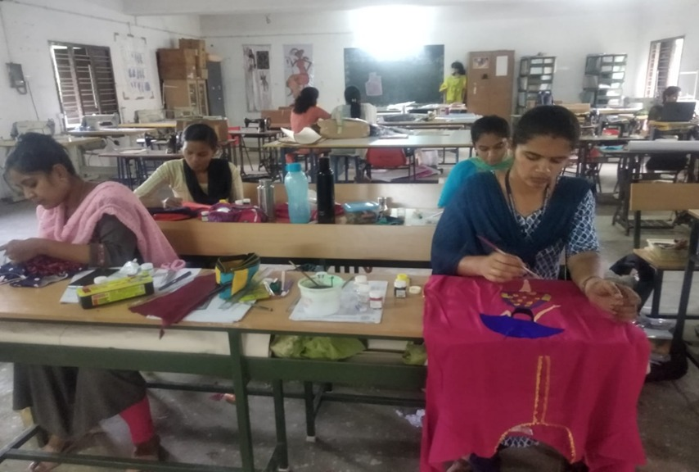
Workshop on Creative Apparel Designing Skills and Techniques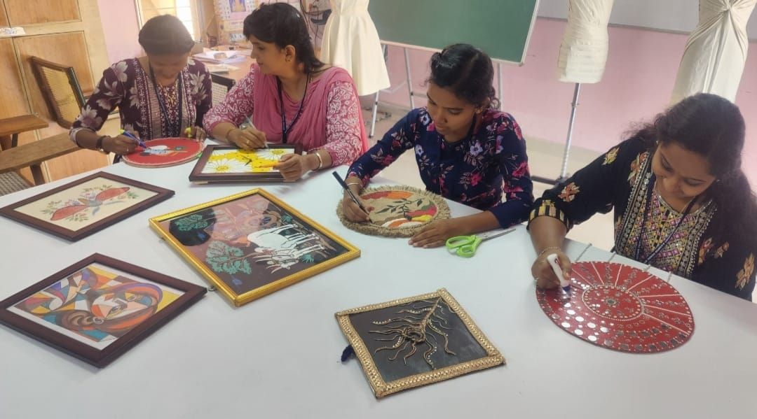
Hands-on Training Workshop in Creative Home Décor

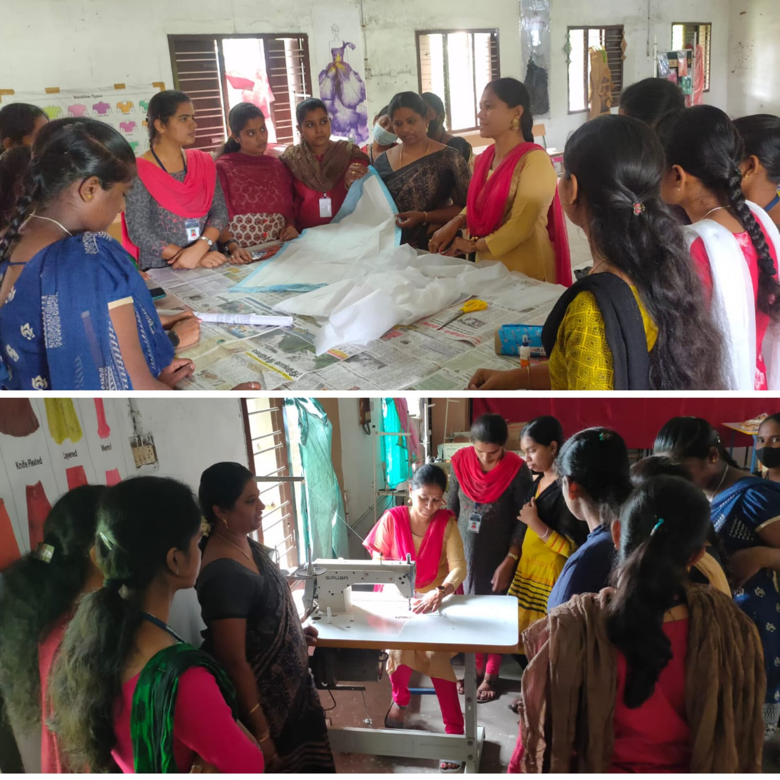
Workshop on Low-Cost Sanitary Napkin Making
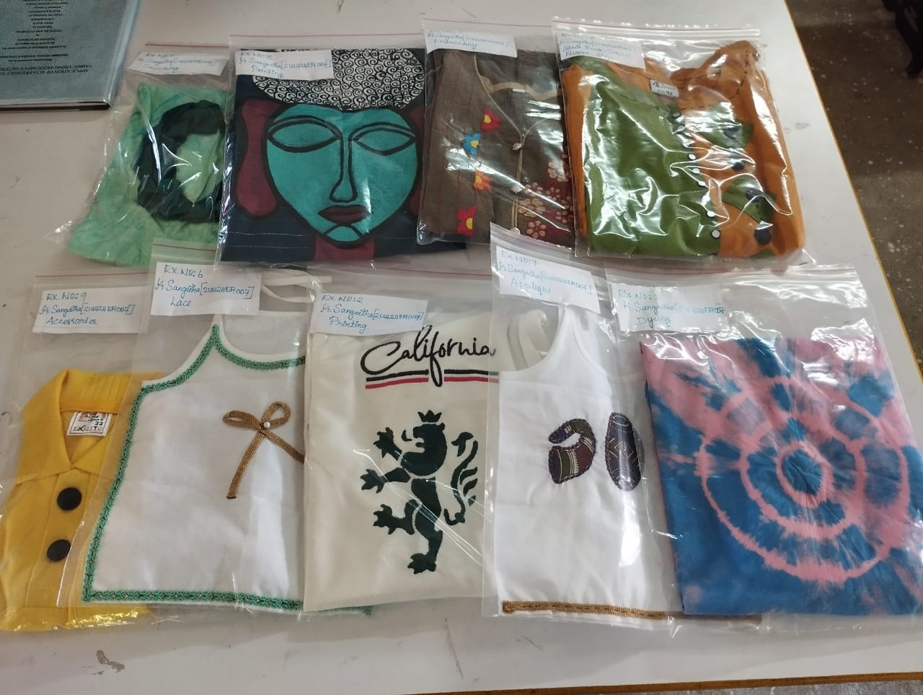
Workshop on Sustainable Printing and Eco-Friendly Dyeing Techniques
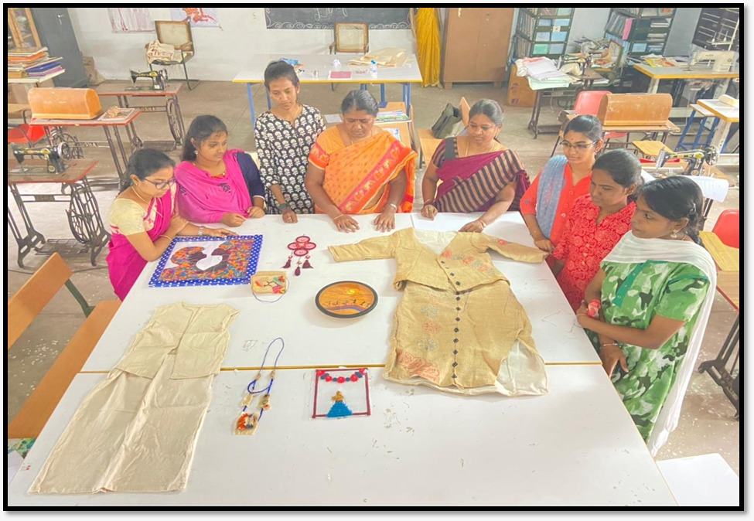
Workshop on Traditional and Modern Accessory Designing in Textiles and Clothing
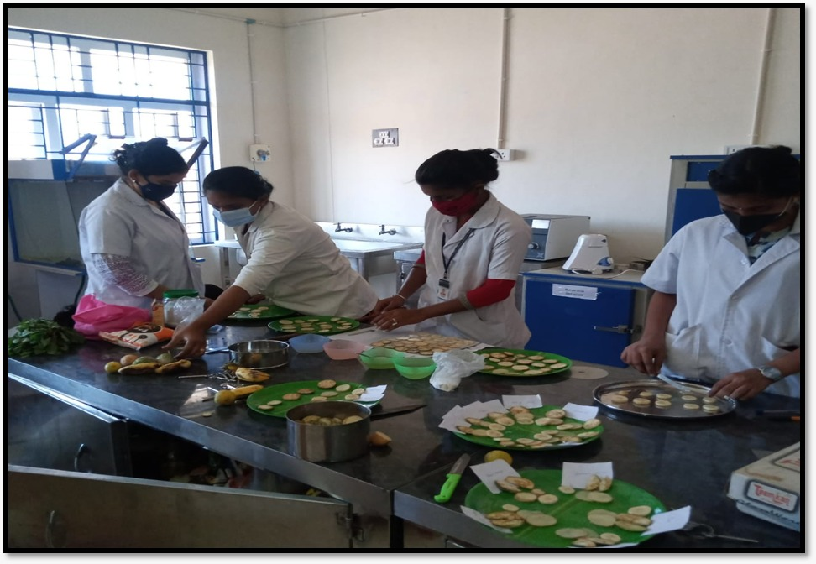
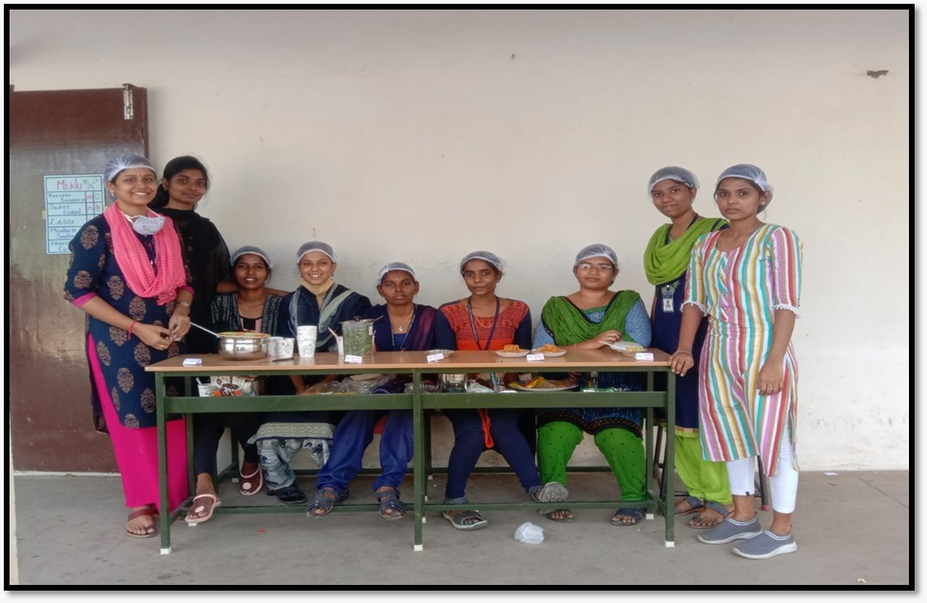
Hands-on Training in Value-Added Food Product Development
Workshop on Low-Cost Nutritious Food Products

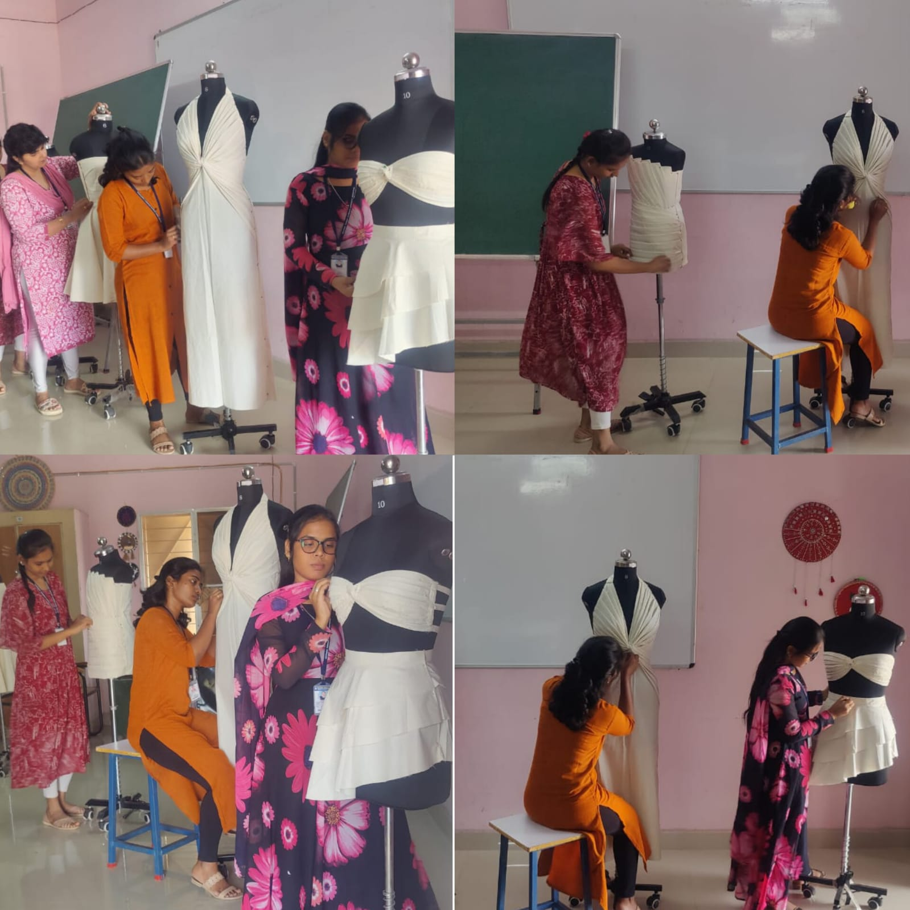
Workshop on Draping Techniques
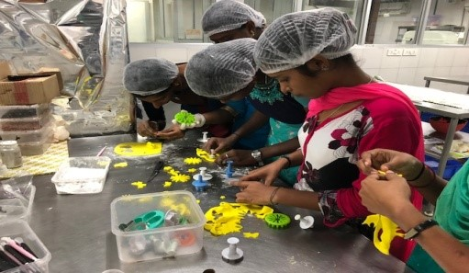
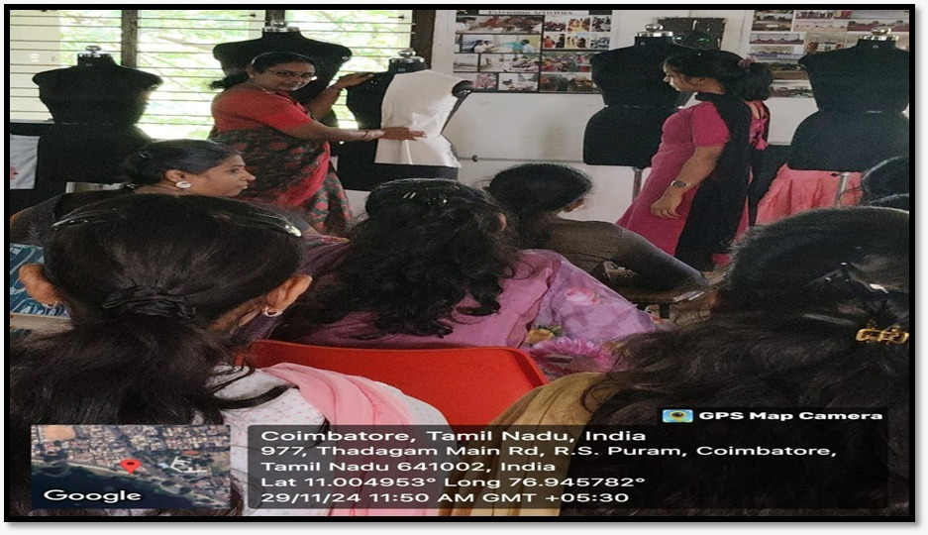
Hands-on Training in Cake Baking and Decoration
Workshop on Basic Fabric Draping Techniques
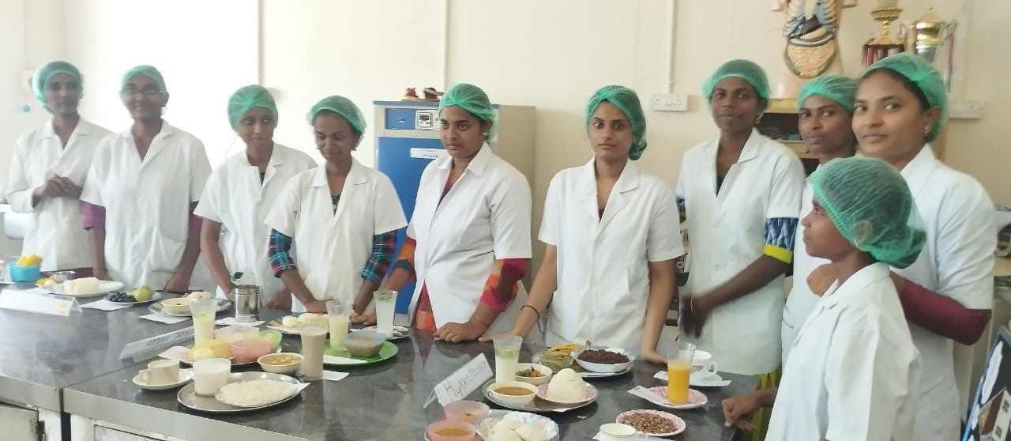
Workshop on Balanced Diet Planning and Demonstration of Nutrient-Rich Meals
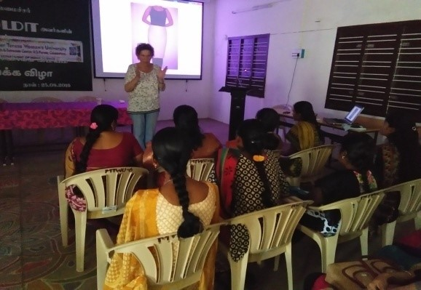
Workshop on Pattern Making and Garment Construction
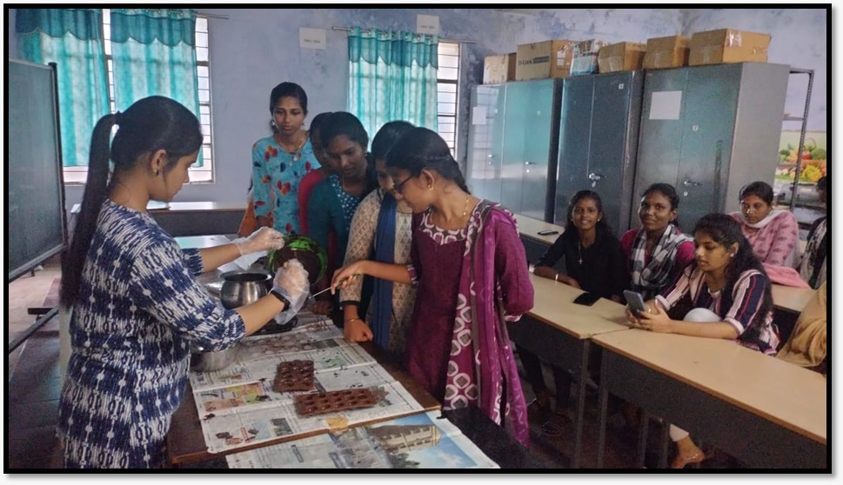
Workshop on Chocolate Making
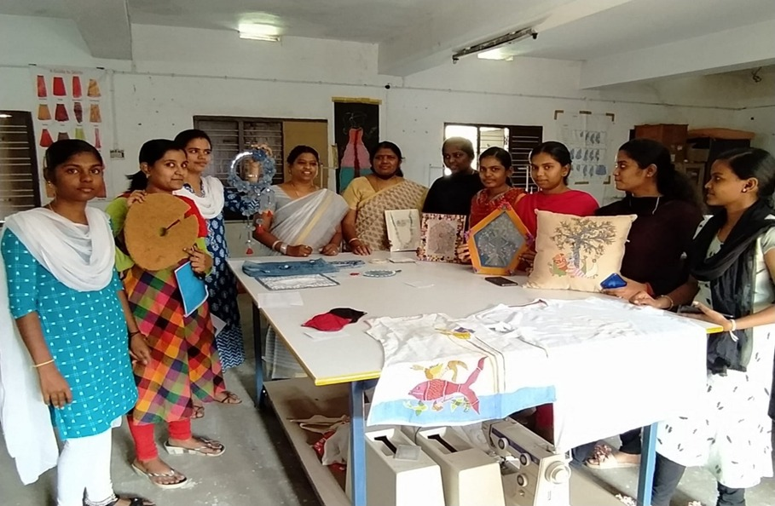
Workshop on Sustainable Product Development
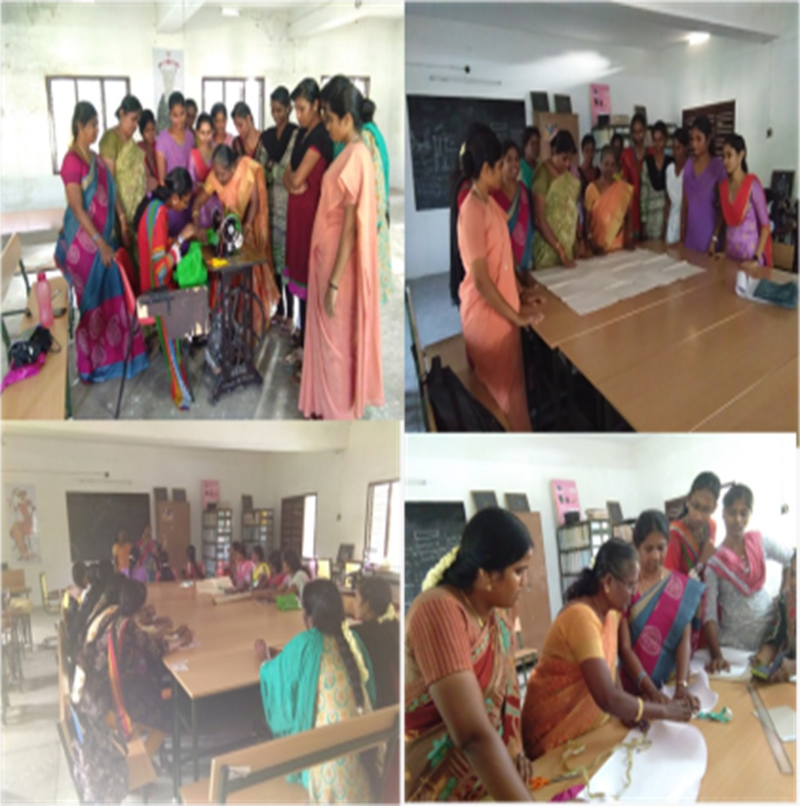
Hands-on Training Workshop on Blouse Designing and Pattern Drafting
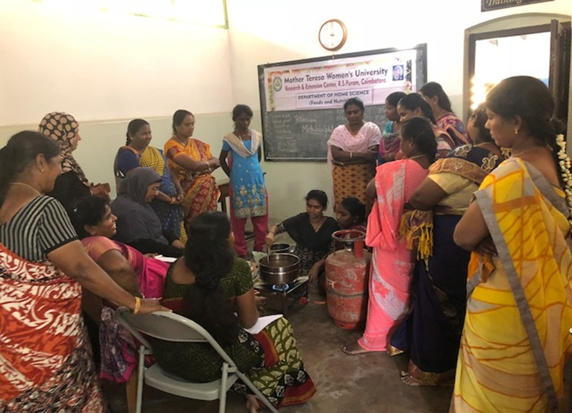
Interactive Workshop on Balanced Diet and Healthy Living

