MOTHER TERESA WOMEN’S UNIVERSITY KODAIKANAL
WORLD MENTAL HEALTH DAY
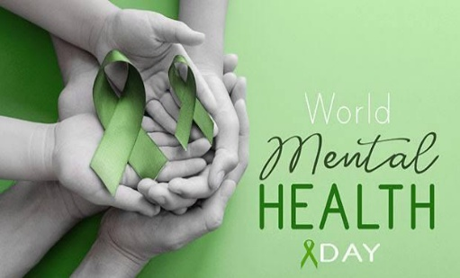
Department of Sociology and Social Work

Time:11.00 am Venue: NKN Lab, library
Date:10.10.2025

The Department of Sociology and Social Work, Mother Teresa Women’s University, Kodaikanal, in collaboration with Athma Mind Care Hospital, Trichy, observed World Mental Health Day on 10th October 2025 at 11:00 a.m. in the NKN Lab. The programme aimed to create awareness about the importance of mental well-being and to encourage students to develop a positive approach towards emotional and psychological health. The event promoted open discussions to reduce stigma surrounding mental health and to empower young women to seek support when needed.
The programme commenced with a warm Welcome Address by Dr. A. Muthulakshmi, Assistant Professor and Convener, Department of Sociology and Social Work. The Presidential Address was delivered by Dr. K. Kala, Honorable Vice-Chancellor, Mother Teresa Women’s University, who emphasized that nurturing mental health is essential for leading a confident, resilient, and meaningful life. A Felicitation Speech given by Dr. A. Clara Dhanemozi, Controller of Examinations, MTWU.
The Chief Guest, Mr. J. Karan Louis, Head Community Social Worker and Project Director (The Mind Club), Athma Psychiatric Hospital, Trichy, delivered an insightful session focusing on stress management, emotional expression, self-care practices, and the importance of seeking help without fear or hesitation. Another special address was delivered by Mr. Solomon I., Managing Trustee and Founder, Nammai Seivom Trust, who inspired the students with real-life experiences of mental health and he especially taught about the brain-rot and its impacts. The vote of thanks given by Ms. M. Priyadharshini, Guest Lecturer, MTWU.As a part of programme, Mr.J.Karan Louis graciously distributed books to the honorable vice-chancellor, faculty members and students, encouraging them to continue expanding their knowledge and understanding of mental health practices. The programme concluded successfully organized and proved to be informative and meaningful for all participants.
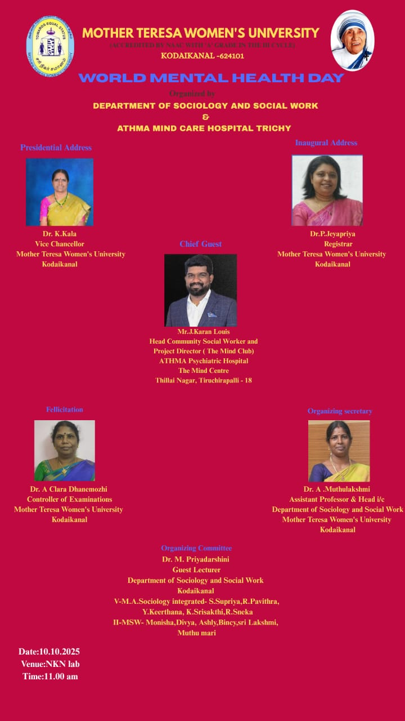
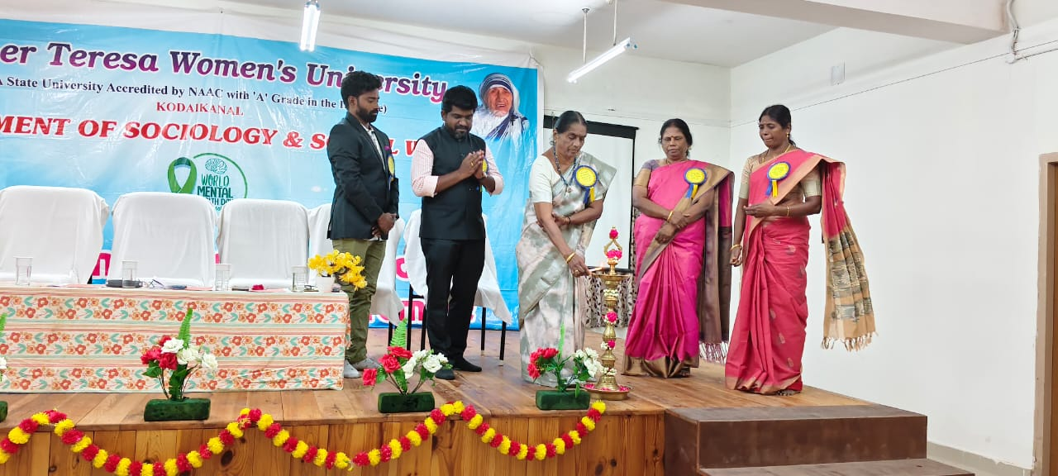
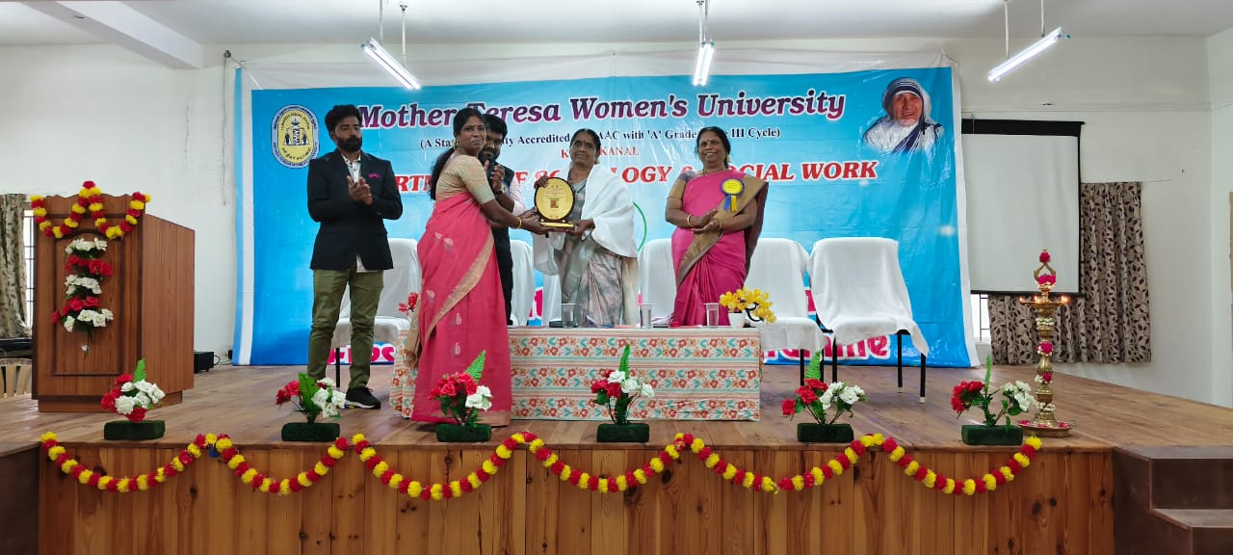
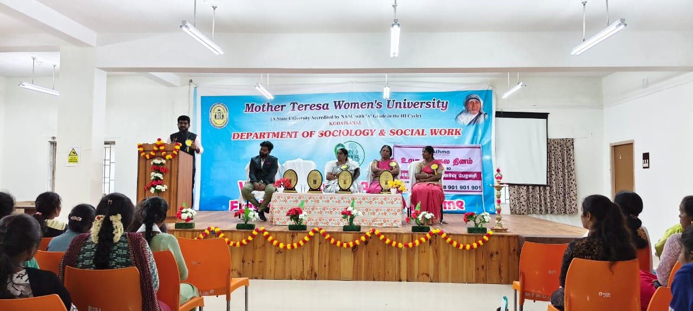

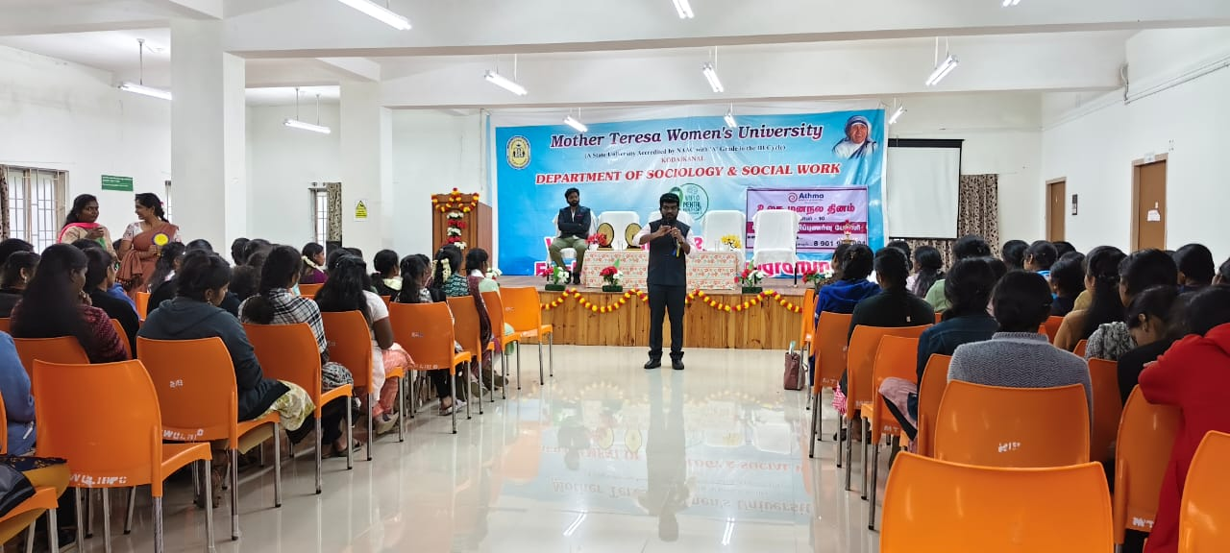
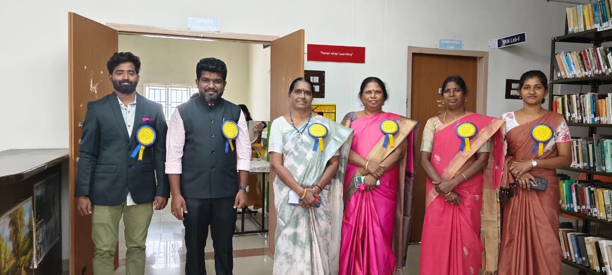
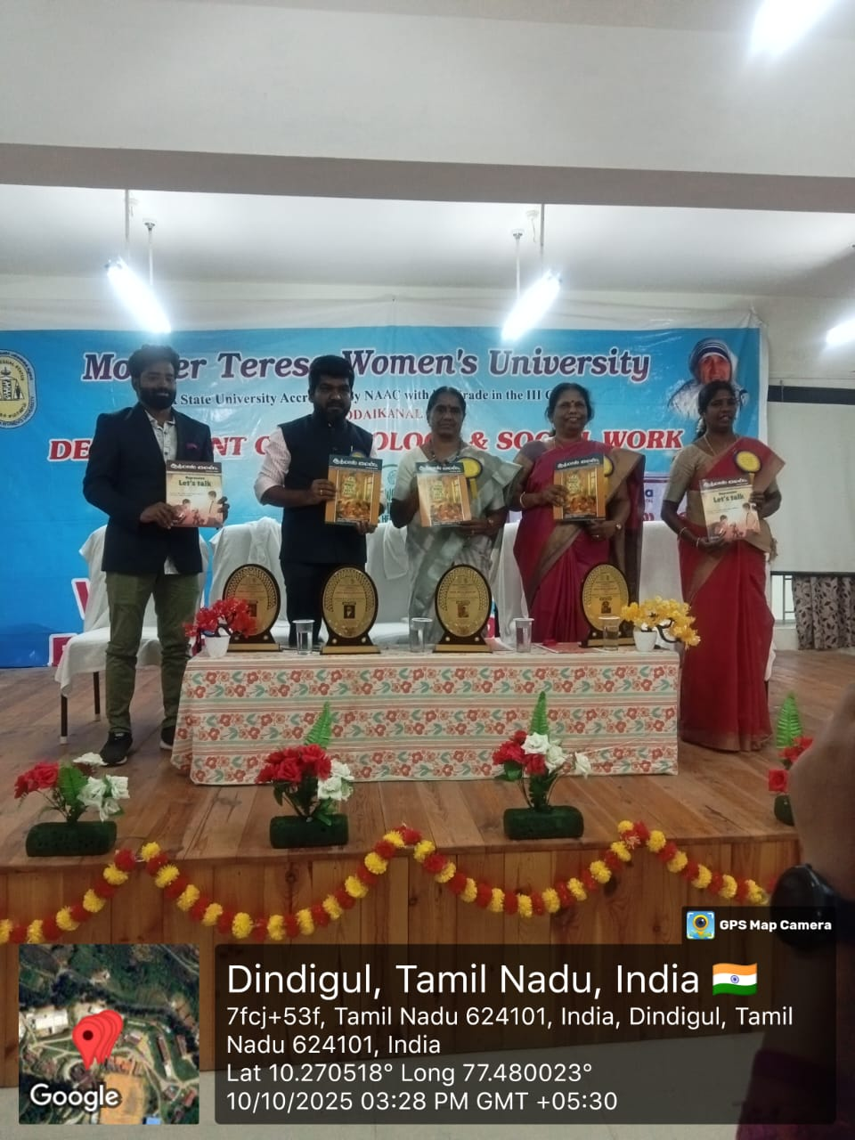
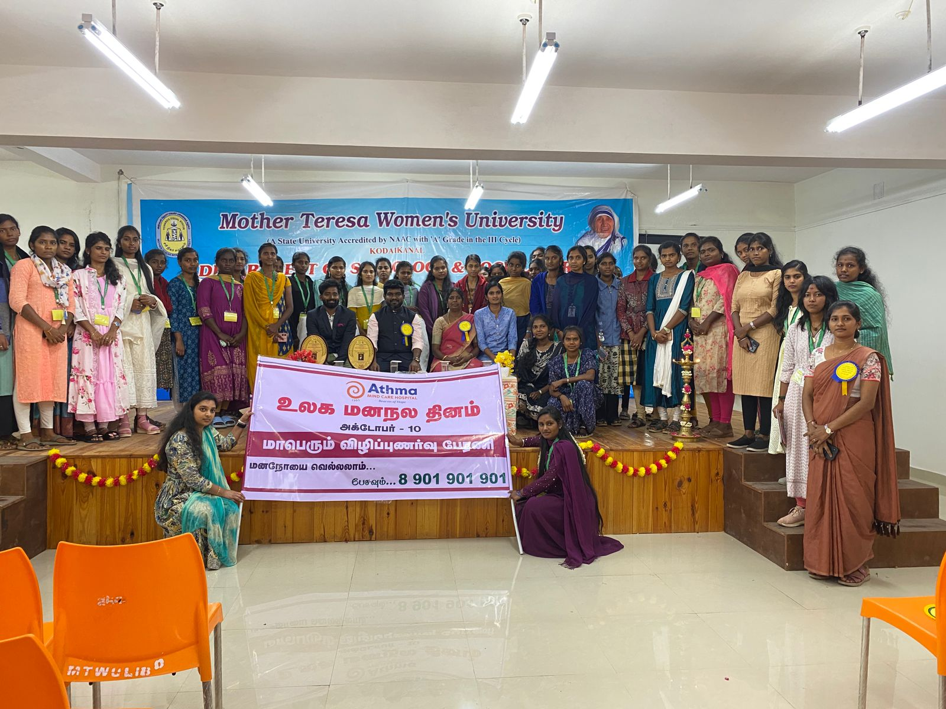
Permission Letter:
