MOTHER TERESA WOMEN’S UNIVERSITY
DEPARTMENT OF SOCIOLOGY AND SOCIAL WORK
REPORT ON
“SPECIAL LECTURE ON RESEARCH METHODOLOGY”
______________________________________________________________________________
INTRODUCTION
A Special Lecture on Research Methodology was organized by the Department of Sociology and Social Work at Mother Teresa Women’s University, Kodaikanal, on 2nd April 2026 at 2:00 PM. The main objective of the lecture was to enhance students’ knowledge and understanding of research methodology and to provide practical insights into conducting research in the field of social sciences. The program was conducted at the Department of Sociology and Social Work and was attended by faculty members, research scholars, and students with great enthusiasm.
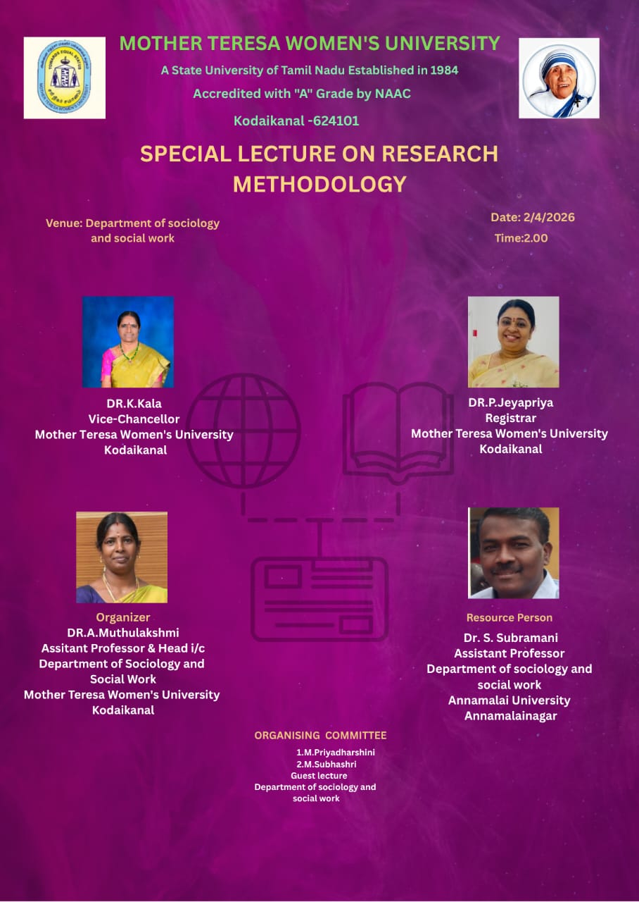
The program was organized under the guidance of Dr. A. Muthulakshmi, Assistant Professor and Head (i/c), Department of Sociology and Social Work. The special lecture was graced by the presence of Dr. K. Kala, Vice-Chancellor of Mother Teresa Women’s University, and Dr. P. Jeyapriya, Registrar of the university. The resource person for the lecture was Dr. S. Subramani, Assistant Professor, Department of Sociology and Social Work, Annamalai University, Annamalainagar. The organizing committee members, M. Priyadharshini and M. Subhashree Vaishnavi, coordinated the program successfully.
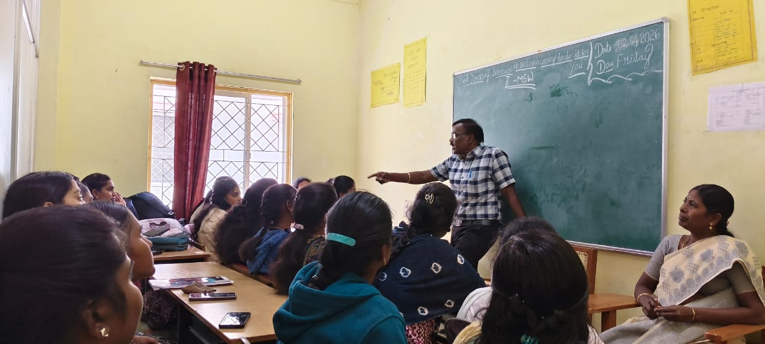 | 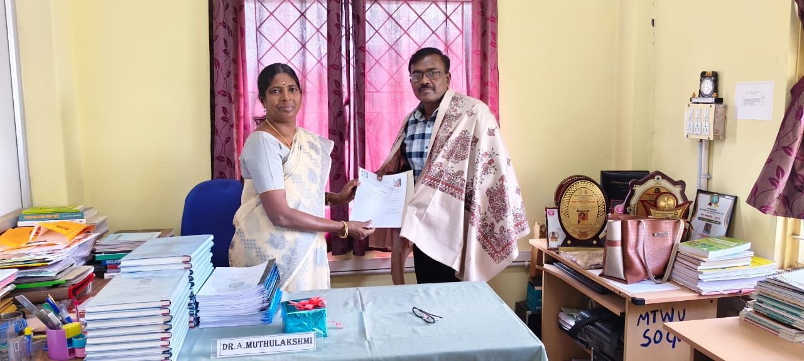
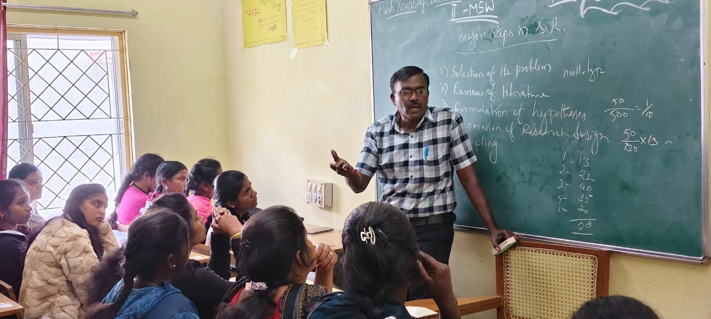 | 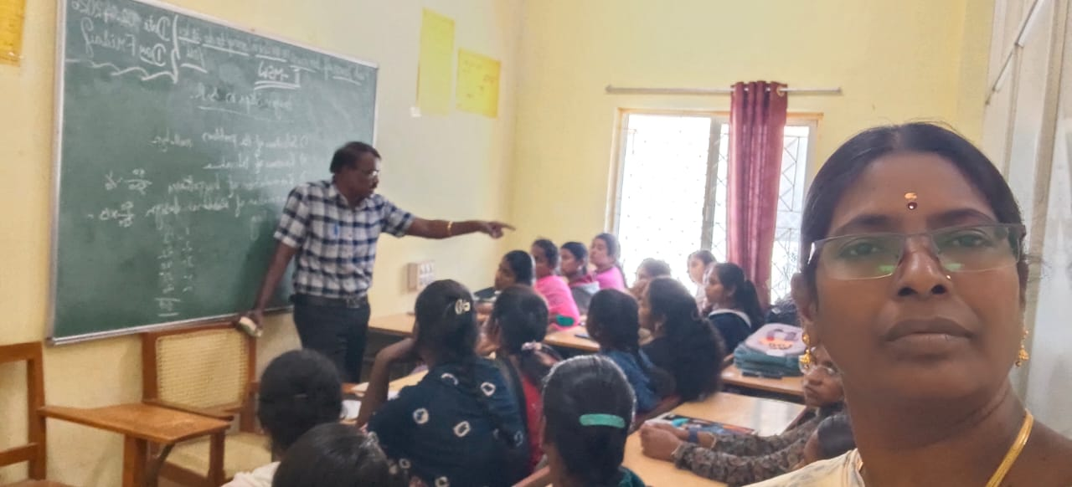

The session began with a warm welcome to the dignitaries, faculty members, and students. The organizer introduced the resource person and highlighted the importance of research methodology in academic learning and professional development. The Vice-Chancellor addressed the gathering and emphasized the importance of quality research in higher education. She encouraged students to develop research skills, critical thinking, and innovative ideas in their academic journey. The Registrar also shared her views on the importance of research and appreciated the department for organizing such an informative and useful lecture for students.
The resource person, Dr. S. Subramani, delivered an insightful and informative lecture on research methodology. He explained the basic concepts of research, including the meaning and importance of research in social sciences. He discussed the process of identifying research problems, framing research objectives, and developing research hypotheses. He also explained different types of research such as qualitative research, quantitative research, descriptive research, and exploratory research in a simple and understandable manner.
Further, the resource person elaborated on various research methods and techniques, including data collection methods such as questionnaires, interviews, observation, and case studies. He explained sampling techniques and the importance of selecting appropriate samples for research. He also discussed the role of statistical tools in analyzing research data and highlighted the importance of accuracy, reliability, and validity in research work. The lecture also covered literature review, ethical considerations in research, plagiarism issues, and the importance of publishing research papers in reputed journals.
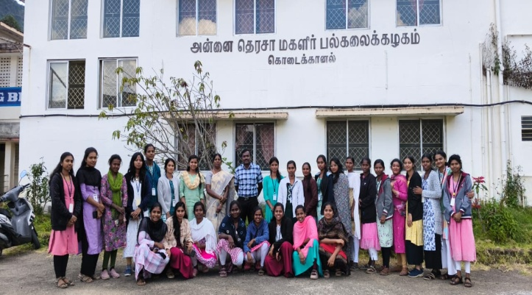 | 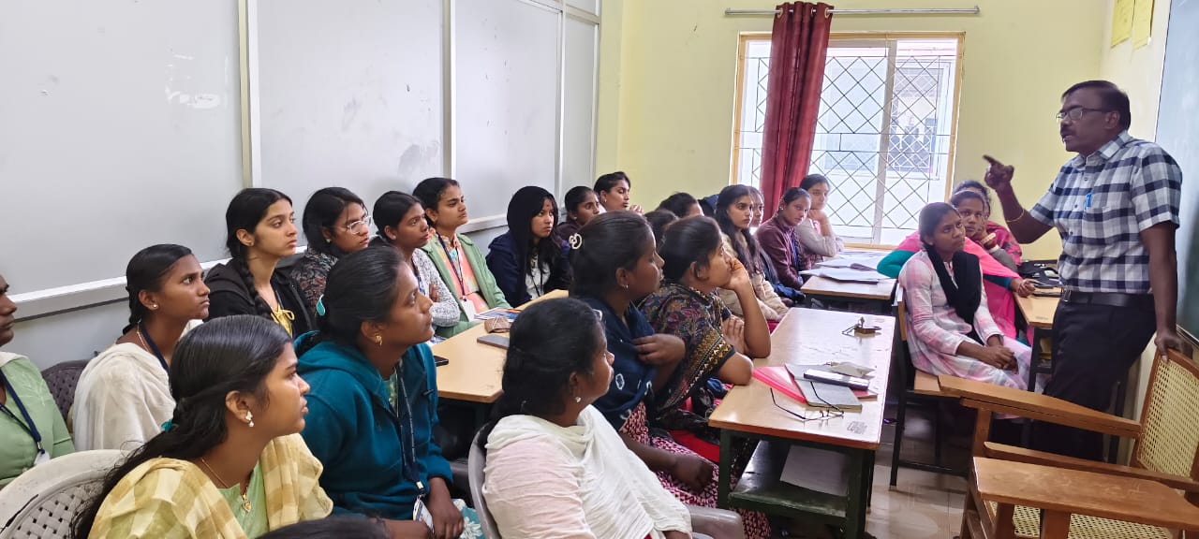

The session was highly interactive, and students actively participated by asking questions related to research proposal writing, data analysis, and research publication. The resource person provided clear and practical explanations with real-life examples, which helped students understand the research process more effectively. The lecture created awareness among students about the importance of research and motivated them to engage in academic research activities.
The program concluded with a vote of thanks, expressing gratitude to the Vice-Chancellor, Registrar, Resource Person, Organizer, faculty members, and students for their valuable presence and support in making the program successful. The organizing committee was appreciated for their efforts in conducting the program smoothly and effectively.

CONCLUSION
Overall, the Special Lecture on Research Methodology was highly informative, engaging, and beneficial for students and research scholars. The lecture provided a clear understanding of research concepts, methods, and practical applications, which will help students in their academic research and future professional development. The program successfully achieved its objective of promoting research awareness and strengthening research skills among students.

