MOTHER TERESA WOMEN’S UNIVERSITY KODAIKANAL
STUDENTS INTERACTION PROGRAMME
Department of Sociology and Social Work


Time:11.00 am, Venue: Seminar Hall,
Date:05.10.2025.

The Department of Sociology and Social Work at Mother Teresa Women’s University, Kodaikanal, organized a Student Interaction Programme on 5 December 2025 at the Seminar Hall, creating an inspiring platform for academic enrichment and dialogue. The event featured an esteemed Associate Professor and Head from Periyar University, Salem, as the Chief Guest, who delivered a motivating address on academic growth and the evolving scope of Sociology and Social Work.The programme commenced with a warm Welcome Address by Dr.A.Muthulakshmi, Assistant Professor and Convener, Department of Sociology and Social Work, followed by a heartfelt felicitation from a senior administrator of the university Dr.P.Jeyapriya delivered an encouraging Inaugural Address, highlighting the importance of interactive learning and motivating students to use such programmes to build confidence and enhance their academic skills.
The Chief Guest Dr.T.Sundara Raj inspired the students by emphasizing the power of knowledge, discipline, and a positive mindset in shaping their future. He encouraged them to stay curious, stay committed, and make meaningful contributions to society through their learning. Ms.M.Priyadharshini, Guest Lecturer, delivered the Vote of Thanks, expressing gratitude to all contributors and participants. Students engaged enthusiastically throughout the session, making the programme a meaningful and impactful experience that strengthened their confidence, curiosity, and commitment to learning.
The Student Interaction Programme proved highly beneficial for the participants, offering a valuable platform for academic exposure, personal growth, and motivational learning. The session boosted students’ confidence by encouraging open communication with the Chief Guest and faculty, while also enriching their understanding of career pathways, social responsibility, and current trends in Sociology and Social Work. Through active discussions, students improved their communication skills and developed a stronger sense of curiosity and engagement. The programme also strengthened the bond between students and teachers, fostered a positive learning atmosphere, and inspired students to participate enthusiastically in future academic activities. Overall, the event created a meaningful space for knowledge sharing, self-improvement, and awareness of societal issues.
The Student Interaction Programme successfully enriched students’ knowledge, boosted their confidence, and created a positive platform for meaningful academic engagement. The event proved to be both inspiring and informative, leaving students motivated to pursue further learning and personal growth.

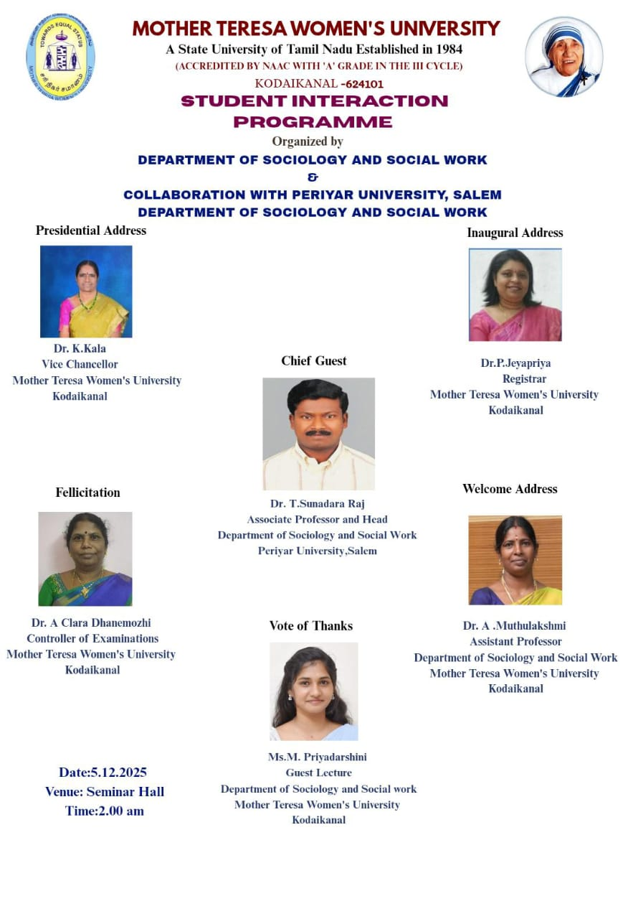
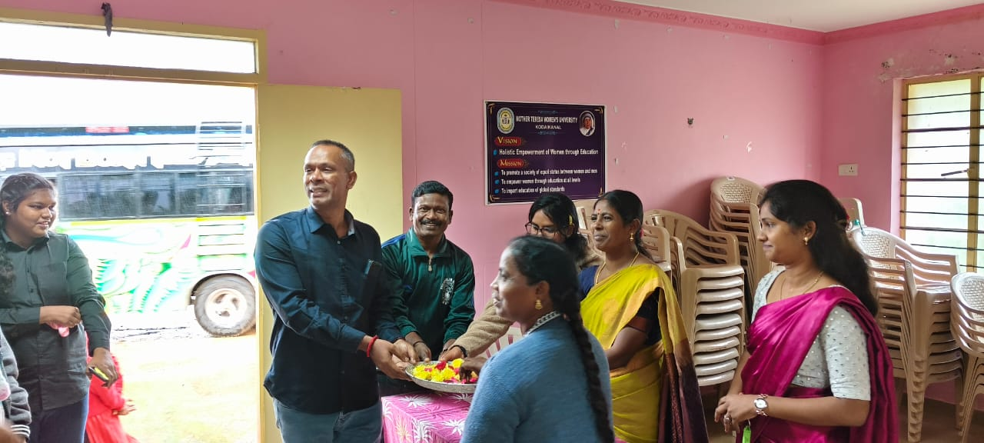
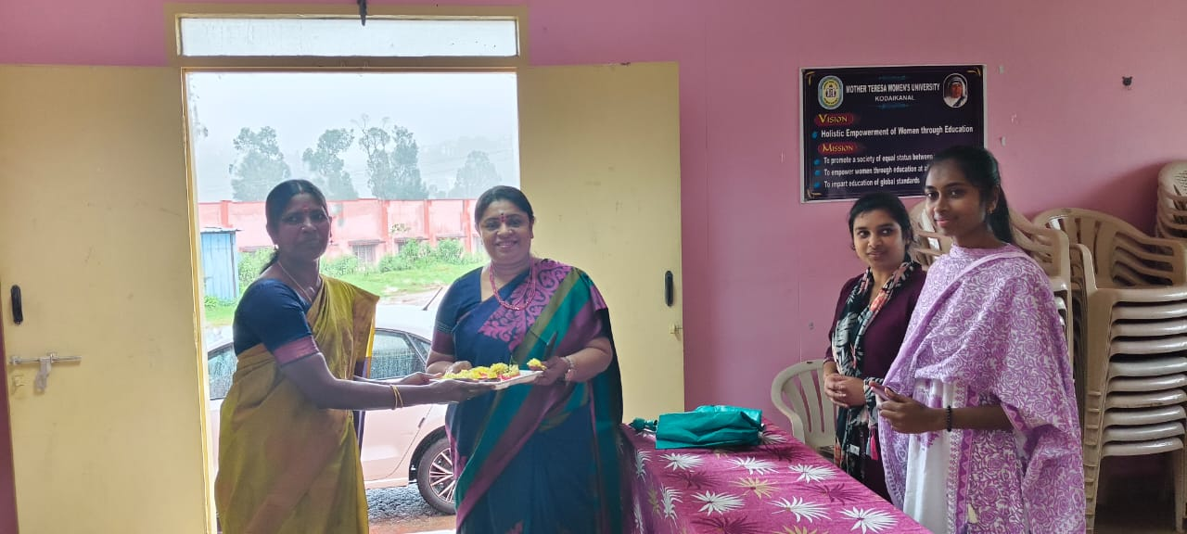
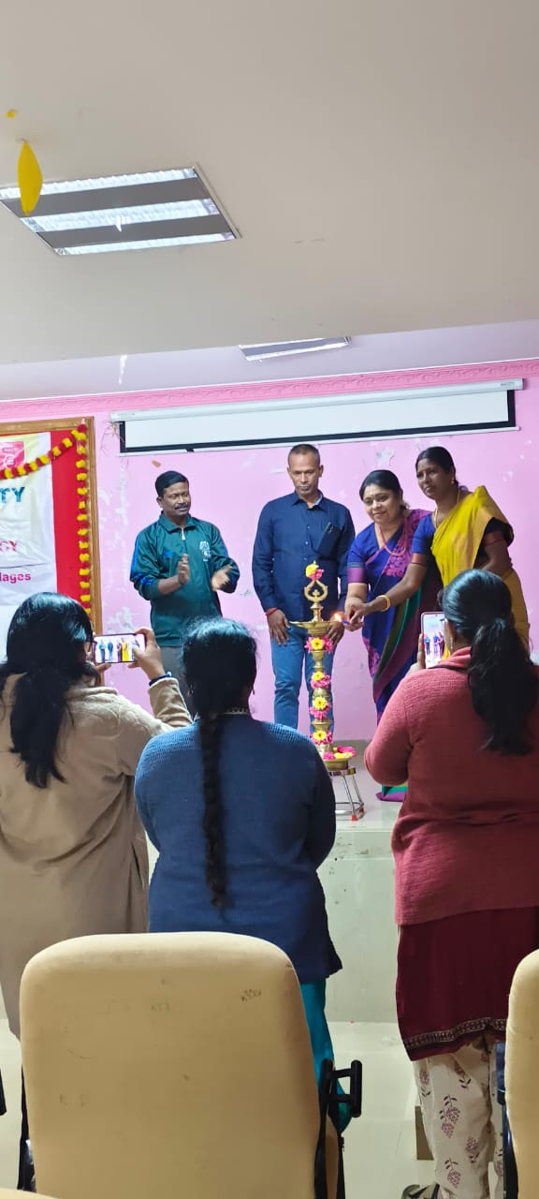
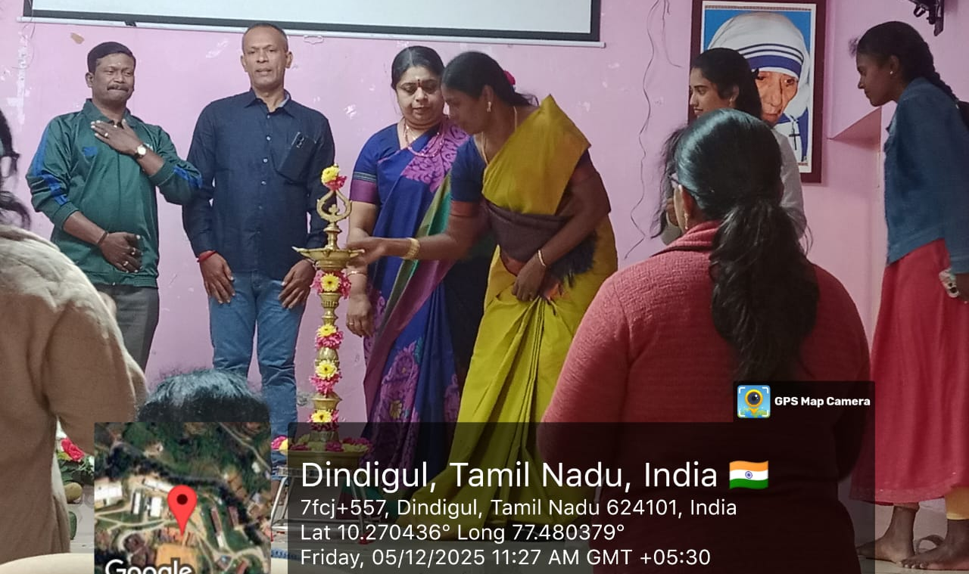
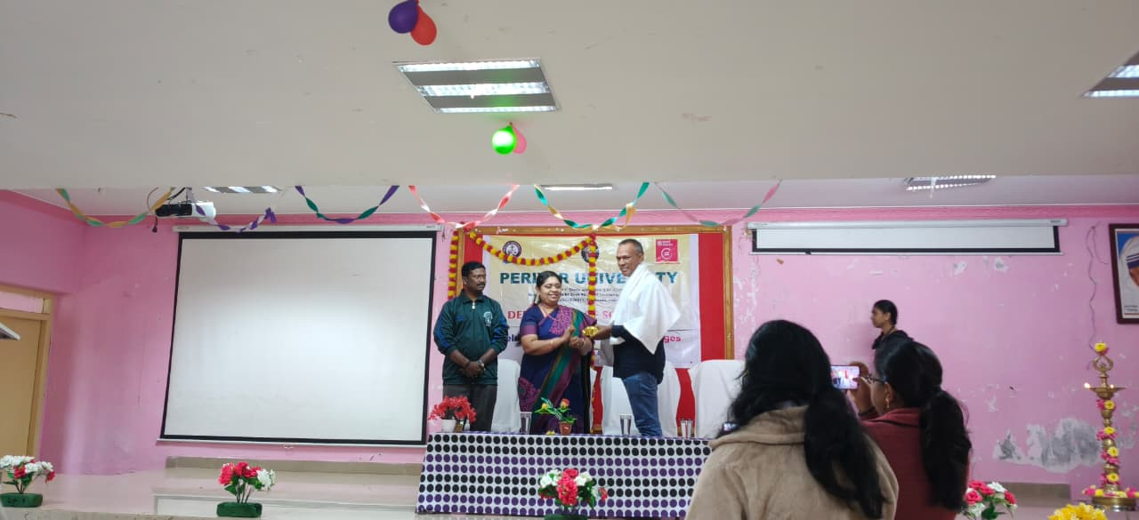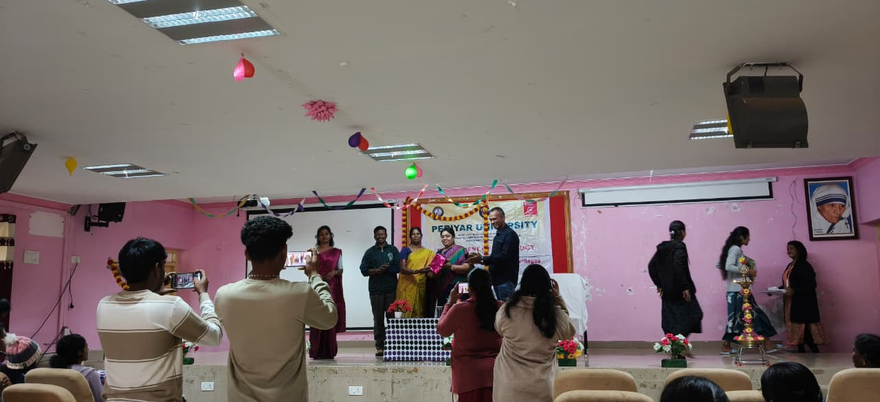
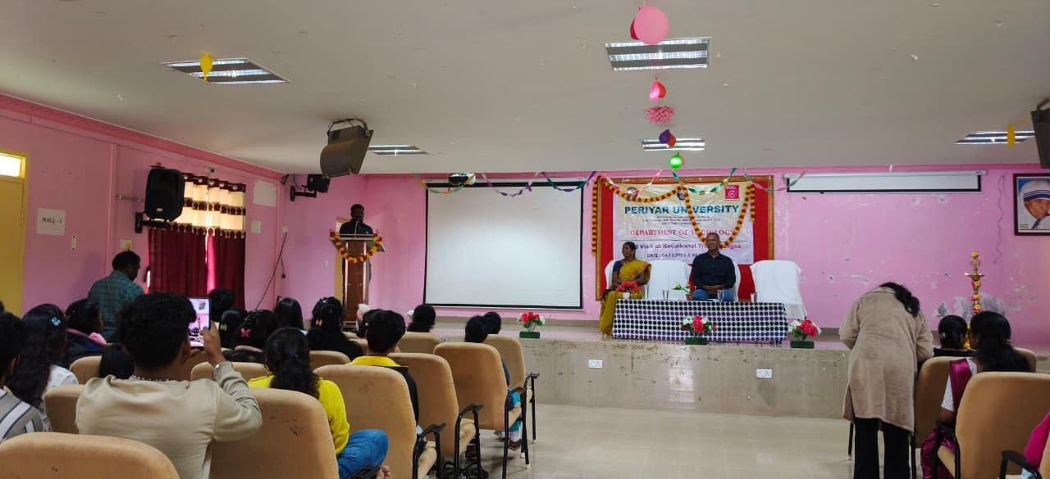
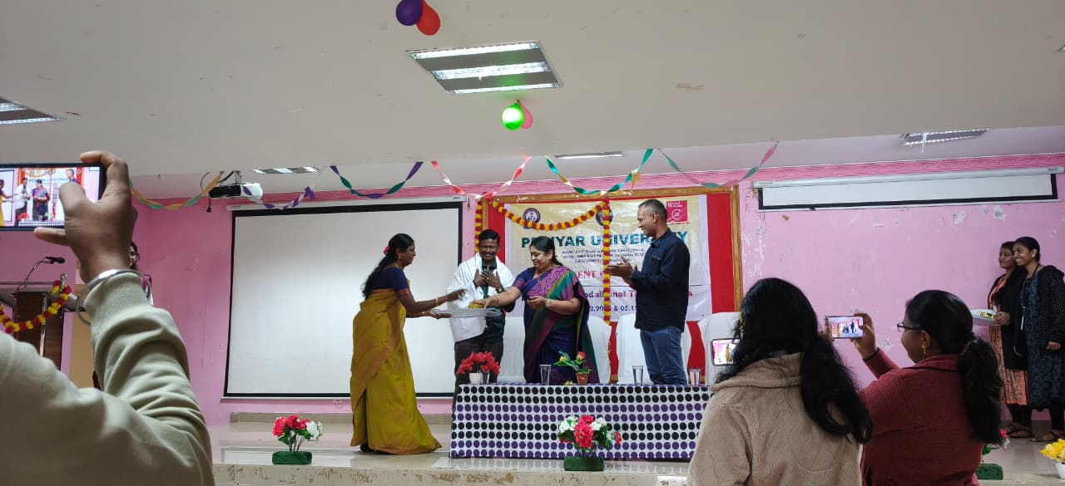
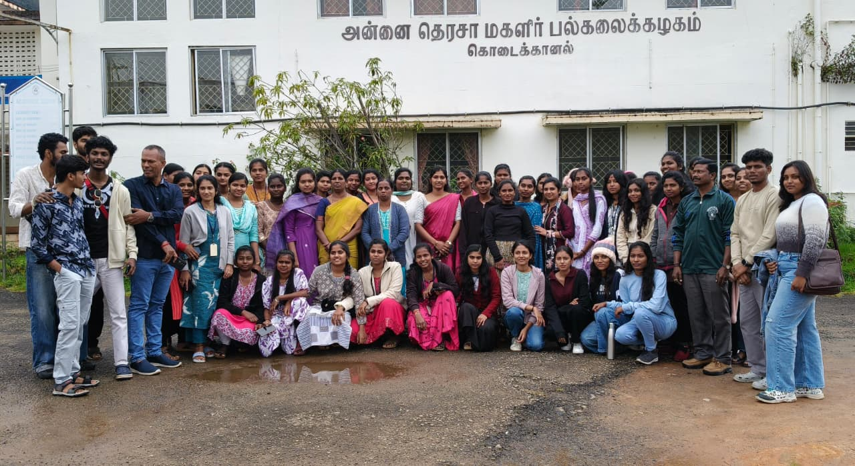
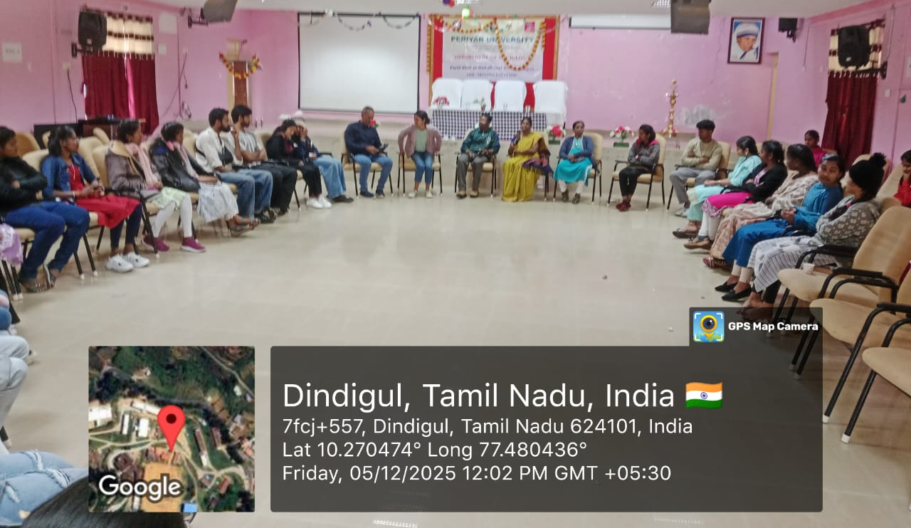
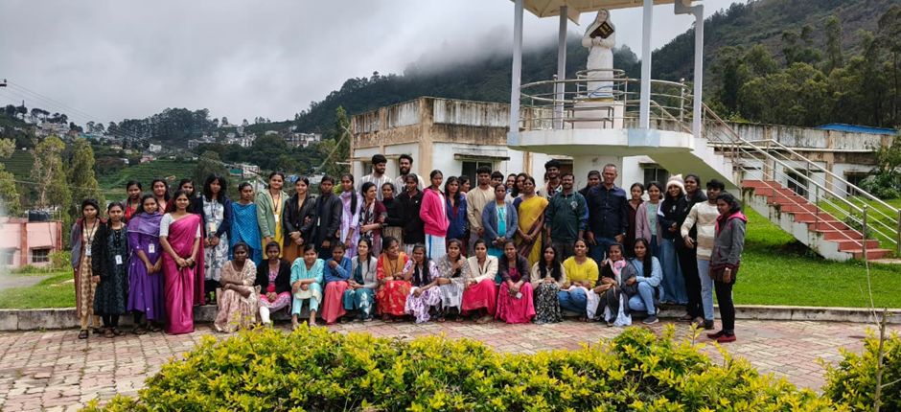

Permission Letter:
